Alumni Meet
The institute organized its alumni meet “LETS REUNITE-17” for all SSIPMTians in Maharashtra on December 28, 2017. The event started at around 11.30 A.M. All the alumni were welcomed by few existing students present at the event. Senior faculty members of all branches of engineering were also present at the meet and Mr. Nishant Tripathi, Chaiman of the institute presided over the event.
In this meet Prof In Charge Prof. Nitin Jain , Head TPO delivered welcome speech with the help of power point presentation. he gave information about current happenings and development in college. Industry Institute Coordinator Prof. Nishant Yadav explained accreditation process and role of alumni in his presentation. Principal Dr Alok Jain addressed the meet. In his speech he asked alumni to come forward with suggestions and guidance so as to institutional growth.
Speaking on the occasion Chairman . Mr. Nishant Tripathi underlined and praised the achievements of Alumni of SSIPMT Raipur in all walks/spheres of life. He felt that it’s a matter of great pride that its Alumni are holding position of responsibility in various Government Organizations, PSU’s, Private Sector, and Academic Institutions. Many of them are successful entrepreneurs providing jobs to others as well. The function witnessed active involvement of the alumnus and a number of commendable suggestions and promising to extend support to current students in the area of training, placement, career counseling and any other help. An Interactive session with the Alumni was very refreshing, all recollecting their memories.. He also thanked all the alumni who were attending the meet and stressed on the role they could play in shaping the culture of the institute.
His address was followed by lunch. A healthy discussion ensued lunch and all the attendees got together for the same. Alumni assured their support and contribution of their choice and interest for betterment of institute. Cultural programs took over soon and all had a trip down memory lane. By 5 PM, the event came to an end and it was indeed an emotional moment for many.

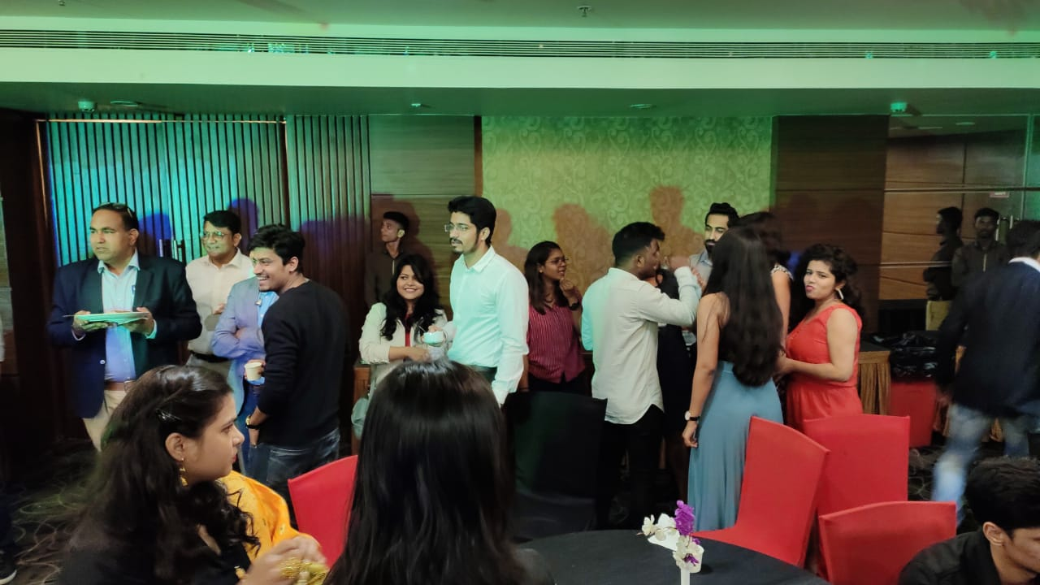
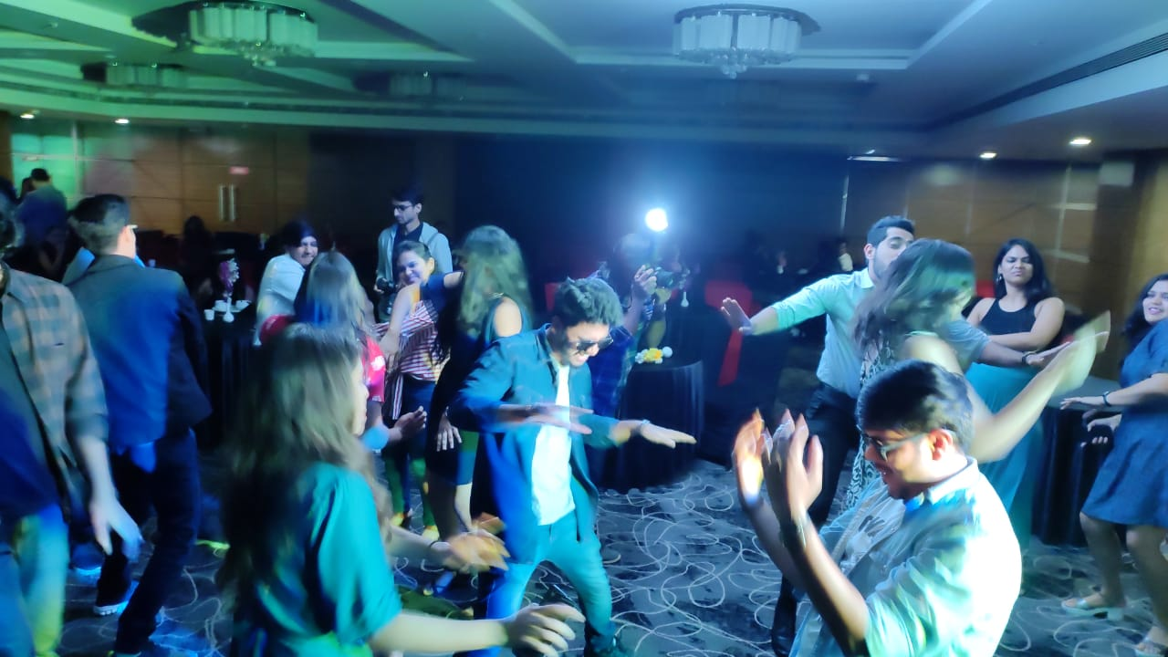

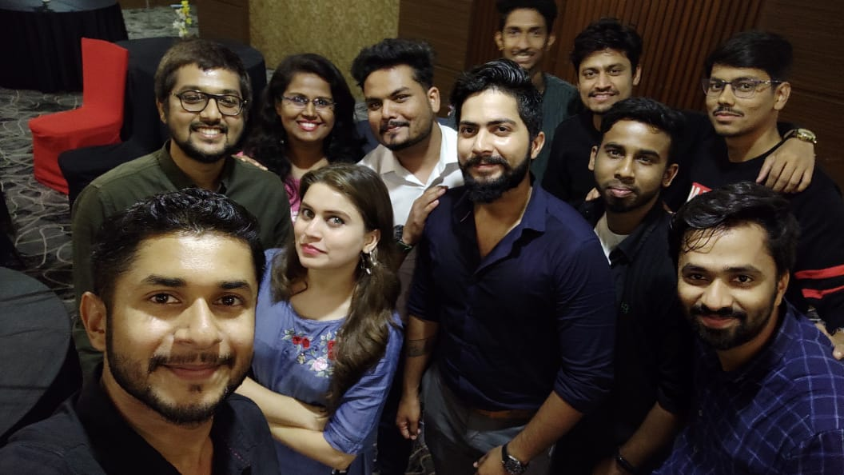
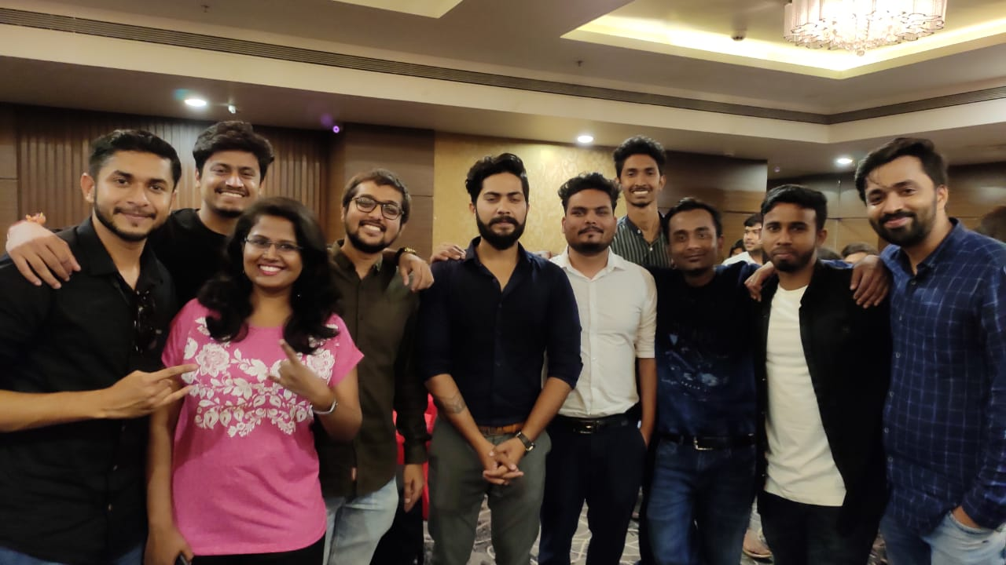

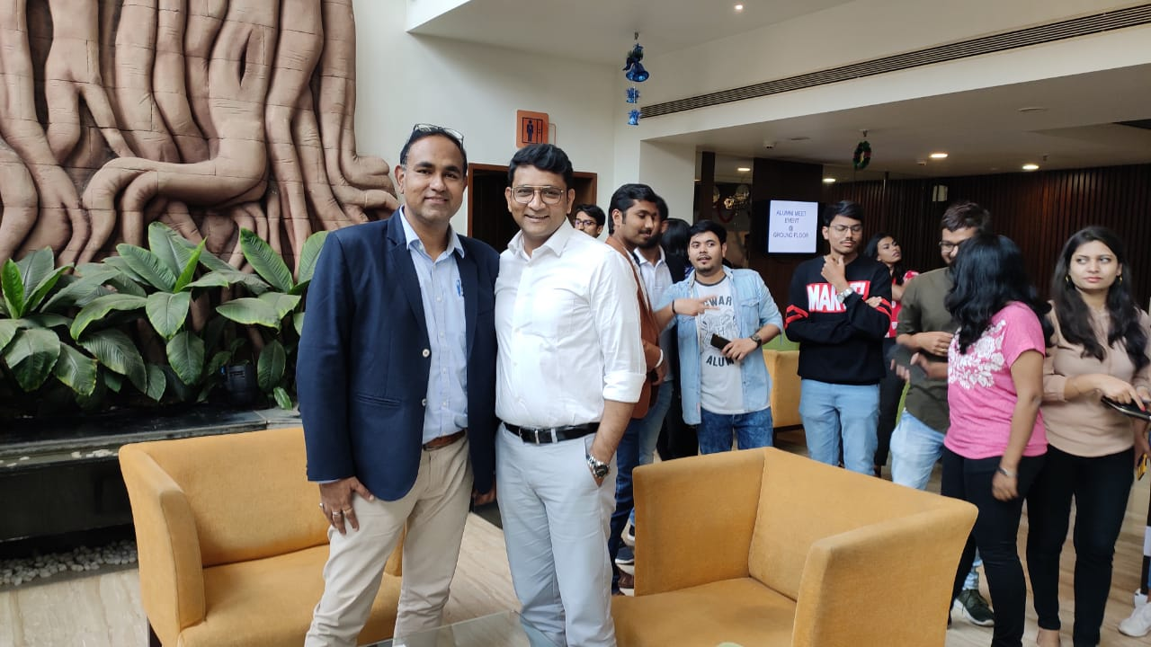
Prepared by Approved by

Praveen Pandey Dr. Alok Kumar Jain

