First Alumni Meet
The institute organized its first alumni meet “RETRACE 2014” for B.E. batches (2008-12 to 2010-14) on October 24, 2014 at Hotel Grand International, Raipur.
The event started at around 11.30 A.M. All the alumni were welcomed by few existing students present at the event. Senior faculty members of all branches of engineering were also present at the meet and Mr. Nishant Tripathi, Chaiman of the institute presided over the event.
Prof. Tushar Vadera, TPO extended a warm welcome to the Alumni and faculty members. He went on to brief the alumni about the fast changes the institute was incorporating owing to the learning curve and urged the alumni to play an active role in shaping the institute and grooming the students in the journey ahead.
Mr. Nishant Tripathi in his presidential address expressed his deep concern on the industry–academia gap and also talked about how the young SSIPMT is all geared up to bridge it. He highlighted how the hard work of the faculty members and students has brought the institute in limelight by consistently being among the top two in overall university results. He also thanked all the alumni who were attending the meet and stressed on the role they could play in shaping the culture of the institute.
His address was followed by lunch. A healthy discussion ensued lunch and all the attendees got together for the same. Alumni assured their support and contribution of their choice and interest for betterment of institute. Cultural programs took over soon and all had a trip down memory lane. By 5 PM, the event came to an end and it was indeed an emotional moment for many. 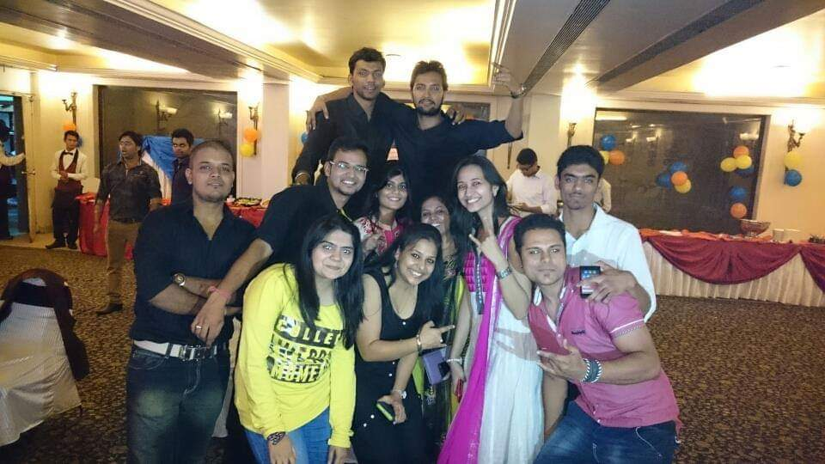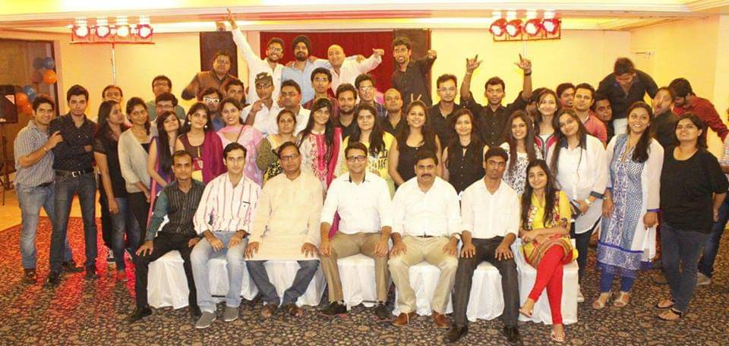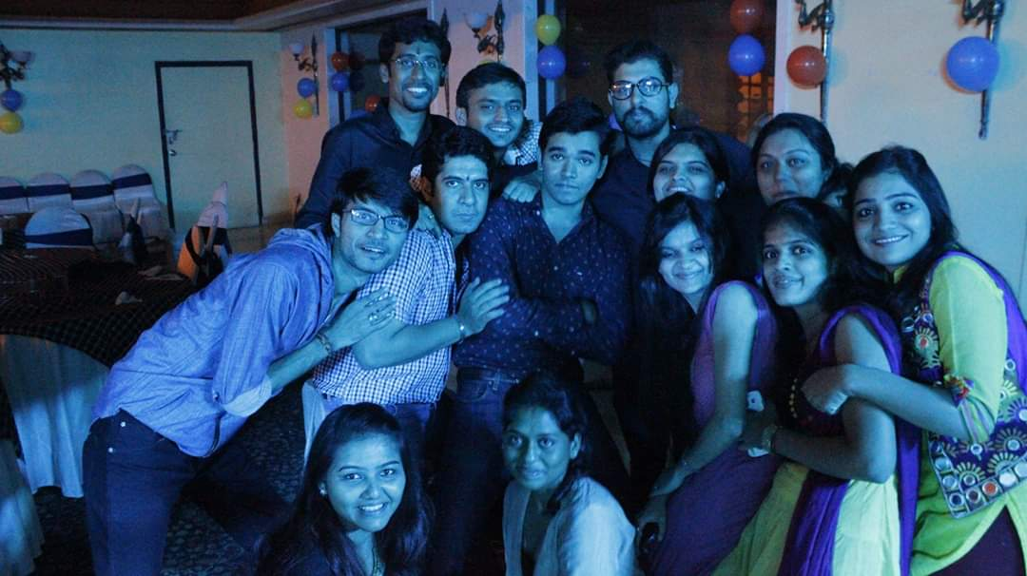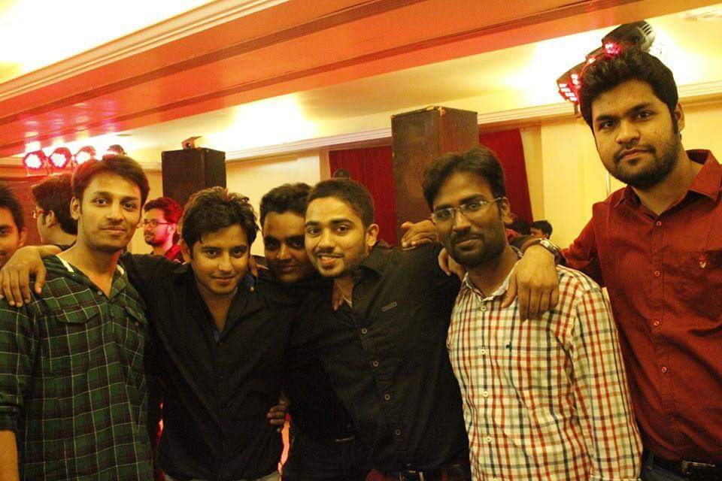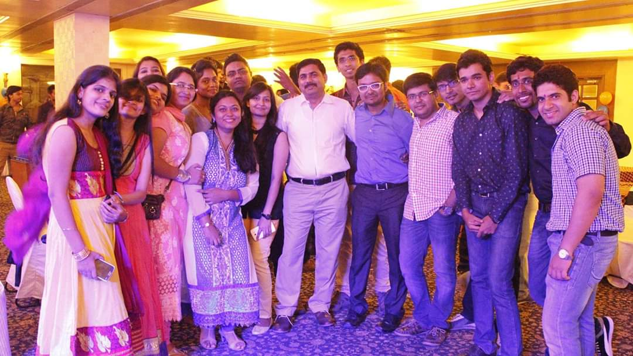
Prepared by Approved by
Akash Gupta, ATPO Dr. M. L. Dewangan

